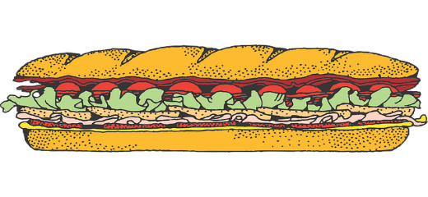
BOY SCOUT TROOP 834
HOAGIE SALE
PROVIDED BY OLLIE’S PIZZA
ITALIAN= $8 TURKEY= $9
ORDERS DUE BY JAN. 31ST , DELIVERED TO SCOUTS AT FEB. 7TH MEETING
….……..NAME………… | ….PHONE…. | ITALIAN ($8) | TURKEY ($9) | OWED | PAID

